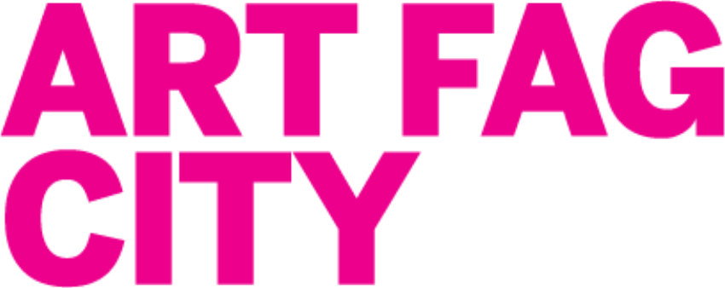

BID FORM

BID(S):
I agree to be bound by the CONDITIONS OF SALE printed in the 2012 AFC Benefit Program. I am aware that my credit card information will only be used in the case of the winning bid.
Signature __________________________________________________

Date___________________________
BIDDER INFORMATION
Bidder Name (print) __________________________________________________________
Billing Address________________________________________________________________
City ____________________________ State __________________________
Zip ______________________
Daytime Phone _______________________________

Evening Phone________________________________
Fax Number _________________________________

E-Mail______________________________________
AFC WELCOMES YOUR BID USING ANY OF THE FOLLOWING
PAYMENT METHODS:
Personal check (payable to New York Foundation of the Arts with Art Fag City in the memo field)

Money Order AmEx Visa MasterCard Discover
Card Number _____________________________ SEC code_______

Expiration Date (mo/yr) ___________

For more information about the AFCRPAAaA*, please contact Corinna Kirsch at 936.697.1902 or corinna@artfagcity.com.

__________________________________________________________________________________________
*still not affiliated with Rob Pruitt

